# Sensact User Documentation

# Introduction

This document describes how to set up and use a Sensact device. But what is a Sensact device?

Sensact is a device which connects what you can do, to what you want to do. It is an AAC (Augmentative and Alternative Communication) device which allows you to connect the switches and sensors which a client is able to manipulate to the actions a client may want to take. It can be used to control a computer, connect to a call bell or control a television and other things.

The device can be configured in many different ways in order to meet the needs of the individual. The flexibility of the configuration makes it possible to adapt the device to the client, rather than demanding that the client adapt to the device.

# Background

*A brief history of the development of Sensact.*

*It is volunteer produced and open source.*

# Cabling

## Power Connections

You can power the Sensact in various ways.

* Connect a USB cable to a computer. This cable has a micro-USB connector at one end and a regular USB connector at the other. You will have received one of these with your kit.
* You can connect the micro-USB connector to a power pack that can deliver 5 volts. Power packs used to provide auxiliary power for cell phones are suitable.
* You can connect a 7 to 12 volt power supply to the barrel jack located below input 1. This can be powered by a battery, or by a transformer which is be plugged into your building’s main power supply.

## Input Connections

There are four input jacks labelled INPUT-1, INPUT-2, INPUT-3 and INPUT-4. The first three are general purpose input jacks. INPUT-4 is for communication with a gyroscope (not included in the current kit).

You should only plug four-wire cables into the general purpose input jacks. Several of these are included in the kit. You can tell whether a wire is four-wire or not by looking at the plug. The plug will have four sections – called the tip, ring 1, ring 2 and sleeve. Thus these wires are called TRRS cables.

TRRS cables are capable of carrying voltage (in the tip), ground (in the sleeve) and two signals (in the two rings). The joystick sends two signals to the Sensact via a TRRS cable – one for up-down motion and one for left-right motion. The two-button sensor included in the kit also connects to the Sensact using a TRRS cable, which can carry the signal for each switch.

IMPORTANT: Do not plug anything other than a TRRS cable into the Sensact input ports. Plugging in a two- or three-wire cable so can short-circuit the board. If this happens, unplug everything including the power source and then try re-connecting.

You probably have some simple buttons you would like to connect to the Sensact. These probably have two-wire connectors. To connect these you use the adapter included in the kit. Connect the “Output” end of the adapter to the Sensact using a TRRS cable. You can then connect 2 simple two-wire switches to the adapter’s input ports.

## Output Connections

There are two output ports on the Sensact labelled OUT-A and OUT-B. These are controlled two optical relays on the Sensact board. You can plug a simple two-wire plug into these ports. When a relay is activated on the Sensact the result is that a switch is closed, connecting the tip and sleeve of the plug. Whatever is plugged into an output port needs to supply its own power. This type of connection is ideal for driving a call bell. This connection needs to be wired so that VCC is connected to the tip and the sleeve is connected to ground.

# Configuration

The configuration of the Sensact is done using a configuration utility which runs on Windows, Linux or Macintosh.

## Getting Connected

Before starting the software you should plug the Sensact into the computer using the USB cable. With the Sensact connected, start the software. The program should detect the Sensact, create the required connections and open the main display.

If the software cannot determine which port to open a dialog will be displayed showing a list of available serial ports and asking you to select one.

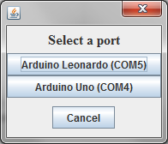

Select the port to which you think Sensact is connected. Don’t worry about selecting the wrong port. The configuration tool checks to insure it is connected to a Sensact device. If not after a few seconds it displays a message telling you it is not connected to a Sensact

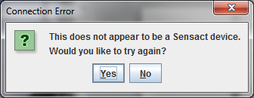

Click on the “Yes” button and you will get to select another port.

## Main Screen

Once the connection is successful you will be presented with the main screen.

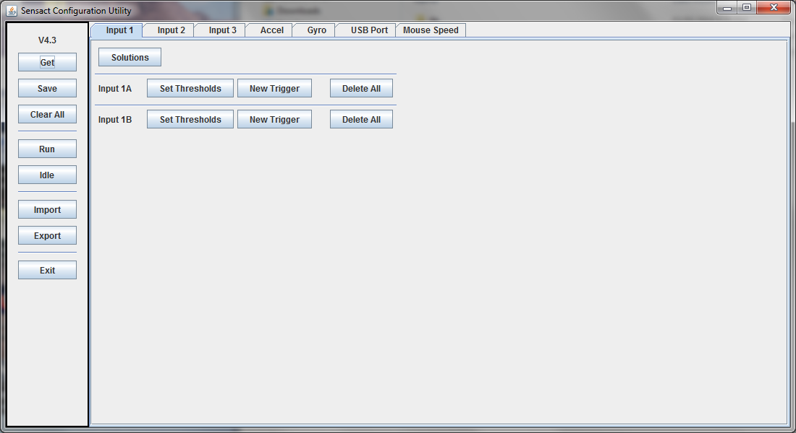

This screen provides you with a visual representation of the Sensact’s configuration. It allows you to modify the configuration as well as saving and loading configurations.

On the left is a column of buttons for useful actions. The purpose of these buttons will be covered as needed in the following sections. A summary is available in the appendix.

Across the top is a series of tabs. The first three (Input 1, Input 2 and Input 3), correspond to the first three input jacks on the Sensact. The next two (Accel and Gyro) are for defining gyroscope-triggered actions. USB Port defines actions to be taken in response to data received from a computer. The Mouse Speed tab allows you adjust the speed of the mouse for mouse-related actions.

In this version of the manual we will not be discussing the gyroscope or the USB port options.

All of the tabs except the Mouse Speed tab allow you to create and manipulate triggers for a set of inputs.

## Simple Actions

Sensact is controlled by a set of *triggers*. A trigger is basically a rule that says “if these conditions are true then do this action”. The simplest condition is the state of a switch or other input device. Actions include mouse controls, keyboard actions, TV controls and others.

### Setting Thresholds

To begin, connect the touch sensor to input 1. Now go to the tab labelled Input 1 and click on the Set Thresholds button for Input 1A. This brings up the following display.

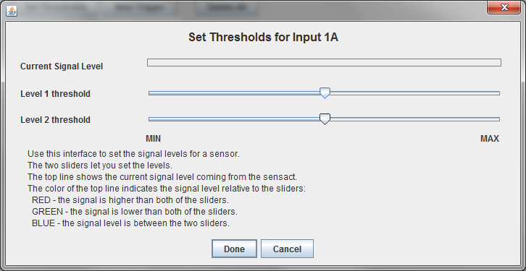

Try pressing the touch sensors. When you touch one of them a red line will appear beside ‘Current Signal Level’. This is showing you that the Sensact is detecting a different signal when the device is touched. An untouched sensor, or open switch, delivers a minimum signal. When touched, the signal level goes close to the maximum.

Close the Set Thresholds dialog by clicking on Done or Cancel.

Now try plugging in the joystick into Input 2. Click on the Input 2 tab and then on the Set Thresholds button for Input 2A. When the joystick is at rest you will see a signal level running a little less than half-way across . Try moving the joystick. One axis of motion changes the signal level for input 2A and the other axis effects input 2B. For the axis effecting input 2A, push the joystick all the way in one direction and then in the other. In one direction the line will disappear. In the other the line will take up almost all the space. You can even try moving the joystick slowly and seeing the signal level change gradually.

By moving the Level 1 and Level 2 sliders you can create three distinct zones – a zone where the signal is below the lowest level, a zone where the signal is above the highest level and an “at rest” zone in the middle. The signal level line will be red when above highest threshold, green – or non-existant – when below the lowest level, and blue when in between.

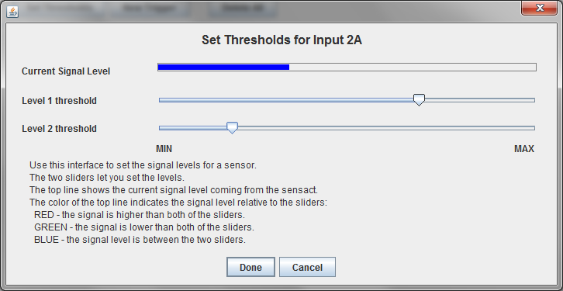

Make sure your display looks like the one above and click on ‘Done’ to save this configuration.

### Creating your first Trigger

With the touch sensor connected into input 1 find out which sensor is connected to input 1A. Now, click on Create Trigger. In the Create Trigger dialog set the text after “and signal is” to greater than level 1. Set the action (after the text “THEN do action”) to Buzzer. Close the dialog by clicking on Done.

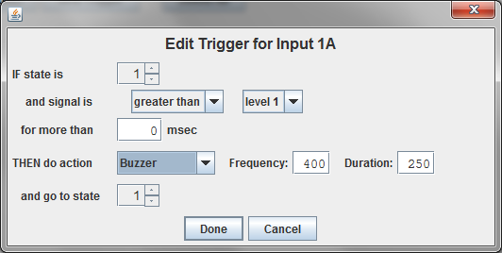

You should see a summary of the trigger on the main screen. Note that there is now a small blue triangle next to the Input 1 tab. This indicates that there are triggers defined on this tab.

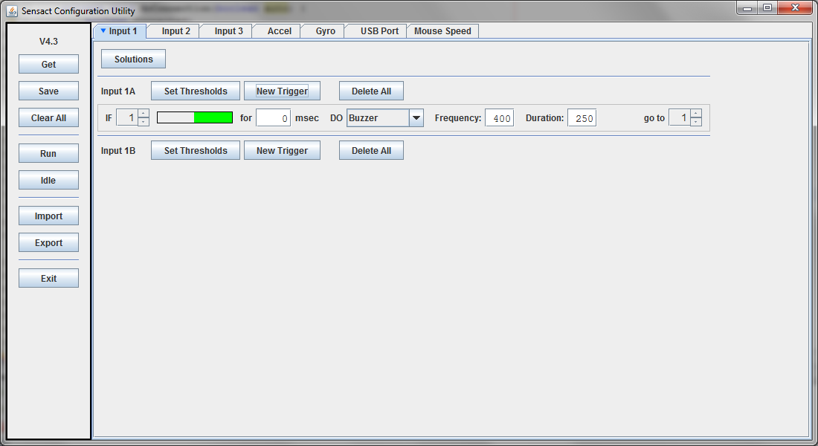

Click on the Save button on the left. This will send the trigger to the Sensact. The Sensact light should flash green briefly and the Sensact buzzer will emit a low-pitched buzz. Now click on the Run button to put the Sensact into “run” mode. Now when you push the button the buzzer should sound.

Congratulations! You have created your first trigger.

Try changing the frequency or duration of the buzzer. Remember to press Save to push the changes to the Sensact.

Now, right-click on the trigger line and select Edit. In the dialog change ‘greater than’ to ‘less than’ and then click ‘Done’. As before, click ‘Save’ and then ‘Run’. Now the trigger only becomes active when the signal is low – that is when you take your finger off the button. Try it. Press the button – nothing happens. Release the button and the buzzer sounds.

## Another Trigger

Go back to the tab for Input 2 and click on ‘Create Trigger’ for input 2A. In the Create Trigger dialog set the text after “and signal is” to greater than level 1. Set the action to ‘HID Mouse’ and in the dialog that appears beside that select ‘Mouse Up’. Your dialog should look like this:

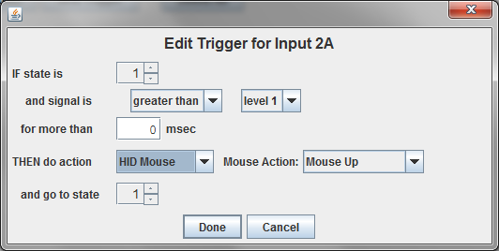

Click on Done.

Create a second trigger, but this time trigger on less than level 2 and make the actin HID Mouse – Mouse Down. Your main screen should now look like this:

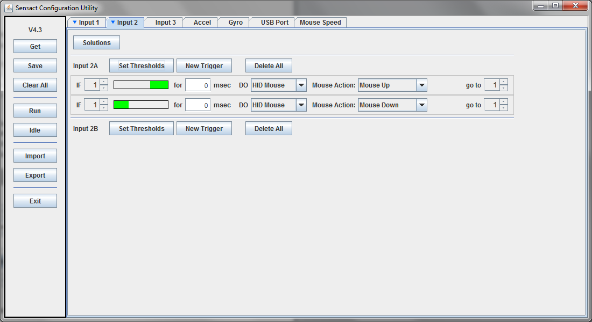

The active signal levels, shown by the green bars, should be at either end of the signal range, leaving an un-active area in the middle. If this is not the case you may need to visit the Set Thresholds dialog again.

Click on ‘Save’ and ‘Run’. You can now use the joystick to move your mouse up and down.

Try changing the joystick to control mouse-left and –right movement. If you are ambitious try programming the other axis of the joystick (Input 2B) to give you complete control of mouse motion.

Note that at this point you could disconnect the Sensact from the computer running the configuration software and connect it to any other Windows, Mac or Linux computer and use it to control the mouse.

## Adding Duration

Let us return to the buzzer action we created for input 1A. Right-click on the trigger line and select ‘Edit’. Set the signal condition to be greater than level 1. In the box beside ‘for more than’ enter 1000. By setting this value to something other than 0 you can require that a certain signal level be achieved *and maintained* for little while before the trigger fires and the action occurs.

Now click on ‘Done’ to close the dialog and, as always, click on ‘Save’ to push the changes to the Sensact.

Now if you just tap the button nothing happens. The buzzer will not sound unless you press and hold the button for at least 1000 milliseconds – which is 1 second.

The ability to add a duration requirement to a trigger may not seem like much at this stage, but it is one of the key components to getting a complex of responses from a single button.

## More Complex State-Driven Actions

Every sensor has a state. A state is just a number between 1 and 15 that the Sensact assigns to each sensor. When the Sensact is powered up every sensor starts with a state of 1.

The state is part of the conditions for a trigger. A trigger will only generate the associated action if the state, the signal level and the duration are all correct.

Part of the action can be changing the state of a sensor.

Let’s create a simple example. Start by clicking on the ‘Clear All’ button on the left. This deletes all triggers for all sensors. It is a handy way to get a clean start. Click ‘Yes’ in the warning dialog when it appears.

Create a trigger for the button on Input 1A, just like the first trigger you created. When the signal is greater than level 1 for more than 0 msec Then do action Buzzer. This time, when the action occurs go to state 2.

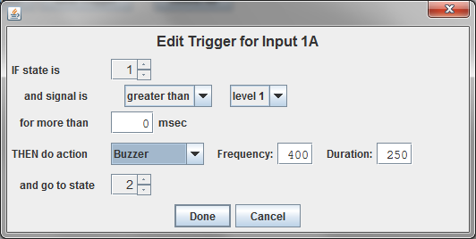

Click on ‘Done’ to close the dialog, and then on ‘Save’ to push the trigger to the Sensact. Click on ‘Run’ as well, to make sure the Sensact is in run mode (more on modes in the appendix).

Now if you press the button the buzzer will sound and the state will be changed to 2. If you press the buzzer again no action will occur because there is no trigger associated with state 2. We need to add something.

We can create a trigger which will bring us from state 2 back to state 1 when the button is released. That trigger definition looks like this:

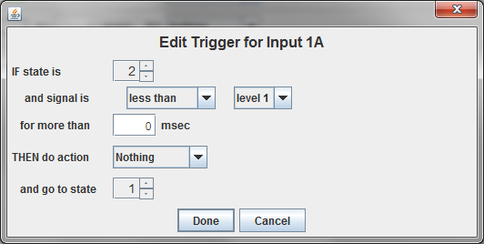

Add this trigger and click on ‘Save’ again. Now the buzzer should sound each time you press it.

This is not very useful, but what if we add a duration requirement to the second trigger? Try setting the required duration for this second trigger to 1000 (1 second) (and saving of course). Now the sensor will only return to state 1 if the button is released for a full second. Try tapping the button quickly. The buzzer will sound on the first tap, but not on the subsequent ones.

This configuration could be used if a client with a tremor needs to be able to generate an action only once, even though he cannot help but press the button several times.

## Using the Built-In Solutions

Using states it is possible to configure input devices so they can create complex sets of actions. However, working through all of the details of state transitions for a multi-function button can be a major undertaking.

In order to simplify setting up the Sensact, the configuration tool contains a number of pre-defined solutions, accessed via the ‘Solutions’ button. As more useful solutions are identified they will be added to future version of the configuration tool.

## Saving and Restoring Configurations